**Indiana University South Bend**

**CAN Styrofoam   
BE RECYCLED?**

**Sustainability Leadership Practicum**

**Spring 2016**

**Lead Researchers: Elizabeth P Morse LEED AP O&M, and Gregory A Frushour LEED GA**

**Executive Summary**

Contrary to popular opinion recycling Styrofoam also known as Expanded Polystyrene(EPS6) is commercially feasible because the current 2016 densified commodity price is approximately $.25 per pound. Unfortunately, few people understand how economically viable recycling EPS6 really is. Among the major issues with recycling in general are the costs of collection, handling (separation) and transportation. Many municipalities and waste management companies have decided not to collect and transport this product. Options for handling EPS6 including buying products that do not come in PS or EPS6 packaging, mailing back the EPS6 packaging for reuse or recycling and densifying the EPS6 for resale. Commercial densification systems are available to make EPS6 transportable.

The current market conditions indicate that the return on investment (ROI) for EPS6 is much better than cardboard. Many municipalities and recycling companies have invested in compaction equipment for cardboard, most likely because they have not realized the business potential of recycling EPS6. Cardboard is the most common recyclable, and it currently trades on the Options Clearing Corporation (OCC) equity exchange in Chicago as a commodity at less than $.04 per pound, it makes economic sense to consider recycling EPS6 at $.25 per pound, April 2016.

There are several ways to recycle and densify this valuable product with hot melt or cool compaction, both with distinct advantages. Cool densification offers the most economical method because this process consumes less energy. Densification allows the recycled material to be reused as the feedstock and limits the need to produce more EPS6 from petroleum and therefore avoiding benzene, a known carcinogen, in the manufacturing process. By using current recycling grant funds available in Indiana, and in other Midwestern states, ROI is greatly increased; In addition cities and municipalities can reduce the amount of EPS6 sent to the landfills.

**Why and How Styrofoam should and can be recycled**

Styrofoam is a registered trademark of the Dow Chemical Company. Commercially, it is known as Expanded Polystyrene (EPS6), which is easily is recyclable and is without question, except for some commercial metals, the most valuable recyclable with a two-year high at $.60 a pound, due to the decline in petroleum pricing, the current price in 2016 is $.25 a pound.[1] However, there is a widely held belief that Styrofoam is not recyclable. This misconception is due in part to municipalities and waste management companies’ decision to not collect and transport the product. A reoccurring problem with all recyclables is the cost of collection and transportation. Without densification (compaction) Styrofoam (EPS6) is expensive to collect and transport. Meanwhile, Municipal Solid Waste Districts have invested tens of thousands of dollars in cardboard balers (compactors) even though cardboard is compostable, breaks down naturally and has a recycled commodity price currently at under $.04 per pound. Available commercial EPS6 recycling systems cost under $35,000 and the State of Indiana has grants to cover half of those costs. But without recycling/reuse efforts, EPS6 is among the longest lasting petroleum based product (plastic) in landfills with an estimated life span of at least 500 years.

Styrofoam is formable and lightweight and therefore highly suitable for packaging products. Products which contain polystyrene can be identified by a [recycling triangle logo](http://www.greenlivingtips.com/articles/187/1/Recycling-by-the-numbers.html) with the number 6 inside it, stamped on the item. There are two major types of polystyrene: EPS6 which is white, dull and most commonly used as a packing material and polystyrene (PS6) which can be tinted, is shiny and used for food packing. EPS6 and PS6 cannot be compacted in the same machine. PS6 can be contaminated with food which makes it more difficult to recycle. However, PS6 can be collected and compacted and reused as a feedstock for either waste to energy or scrap plastic to oil projects.

Styrofoam is commonly used to pack food, drinks, fragile and deformable goods. For example, EPS6 is used in mailing materials because it is lightweight, which can reduce the cost of postage. EPS6 is commonly used as packaging for shipping new electronics and appliances. Polystyrene is a derivative of ethylene and benzene. Benzene is a known carcinogen, and yet we routinely pack food into foam clam-shells, heap food onto foam plates and drink hot and cold beverages from these disposable vessels. “Given the nature of polystyrene, it’s surprising that such an energy intensive, oil sucking and toxic substance is allowed to be use as packaging for food; particularly for items such as meat where the food has direct contact with it. Nearly two dozen cities in the USA have banned the use of polystyrene for this purpose.” [2]

In the environment, ingestion by animals can block their digestive tracts causing death through starvation. Styrofoam, EPS6, is also abundant in the [Great Pacific Garbage Patch](http://www.greenlivingtips.com/blogs/174/Great-Pacific-Garbage-Patch.html). While we can try to buy products that don’t use EPS6 packing, we need to reduce/reuse/recycle the EPS6 that winds up in our hands instead of sending it straight to our landfills. Unfortunately, most curbside recycling programs will not accept Styrofoam due to its volume. It is hard to store and transport due to its light weight. Currently in the U.S. Polystyrene packaging is being recycled at a rate of less than 12% per year. Considering all the negatives of this product - recycling makes sense - a pound of polystyrene recycled is a pound of new polystyrene that will not be created from the finite resource petroleum. Both types of polystyrene can be recycled and reused by different methods. But most polystyrene products are currently not recycled due to the lack of incentive to invest in the compactors and logistical systems required.

**Municipalities with Existing EPS recycling**

The recycling of EPS6 and PS6 is concentrated in the population dense North East and California. The exception is Michigan because it is the headquarters of Dart Industries. Dart Industries has developed a program for public drop off recycling of EPS6 and PS6 foam. Dart transports the material from each drop-off location to its Michigan recycling center for reprocessing. All locations accept used polystyrene foam including post-consumer foam cups and "to-go" containers, egg cartons, ice chests, rinsed meat trays, protective packaging foam), and other foam with the #6 inside the chasing arrows triangle.[3] To find a US location that accepts EPS6 and PS6 use the website address. <https://www.dartcontainer.com/environment/ps-foam-recycling/>. Dart is a member of the Post Consumers Plastic Recyclers.

In the state of Indiana there is only one company which is listed as an EPS6 and PS6 recycling center. EFP Corporation is based in Elkhart Indiana at 223 Middleton Run Road. EFP Corp was found on both the Dart website and the http://www.homeforfoam.com/ website. EFP Corporation is a Foam Molding & Fabrication company that provides foam molding products for the automotive and recreational vehicle industries. The company was contacted and reported that they grind and reuse packing grade EPS6 in their products. EPS6 that is not clean they ship to Nature’s Wood Products. EFP also shared that they do not use food containers, PS6, in their manufacturing process and that the drop-off volume for PS6 is low so they send any food containers to the landfill. If they receive EPS materials that are not suitable to their process, they ship the materials to Nature’s Wood Products, where they also ship large bags of EPS6 dust created by their manufacturing process.

Nature's Wood Products, also located in Elkhart, Indiana, provides an EPS6 recycling service. Nature’s Wood Products will provide large poly bags for the collection of EPS6 and will schedule and pick-up the material from commercial companies. Individuals can drop off a carload of EPS6 at their facility. The company was contacted, and they reported that they densify over 3 million pounds of EPS6 a year. They will accept white food grade materials, PS6, including drink cups. They use an industrial scale Sebright Products, Inc. densifier that runs 24 hours per day. They ship most of their densified EPS6 to RAPAC near Memphis, Tennessee, where it is extruded into small resin beads. Nature’s Wood Products receives EPS6 from several of the waste management companies in the South Bend and Elkhart areas. Their major source of EPS6 is from the RV and other industrial industries in the Michiana area.

In the larger Michiana area Berrien County, Michigan, also provides single stream recycling of EPS6 and EP6 from their Southeast Berrien County Landfill facility. Residents of Berrien County can drop- off EPS6 and PS6 foam including: Styrofoam empty and clean “to-go” food containers, foam blocks, foam coolers, and egg cartons. The foam is sent to Waste-Away Group in Elkhart, Indiana. Waste-Away Group uses a Poly-max densifier to compact the EPS6 and PS6 for resale. The firm was contacted and they reported that the volume of household EPS/PS6 was low, and often they did not have enough volume to run the densifier and thus the materials were sent to the landfill. Several of their commercial customers do have onsite densifiers and Waste-Away will pick up the EPS6 for resale.

In the state of North Carolina there is one Dart Industries drop-off location in Randleman located in the central part of the state. The commercial plastic recyclers service commercial clients and will pick-up large amounts of foam for a small fee. Polymer Sciences, Inc. (PSI) based in Collettsville is a full service industrial plastic recycling company. They recycle EPS6, polyethylene, polypropylene, and PS6. There are several firms in North Carolina that will purchase recycled EPS6 for their companies including U.S. Case based in Raleigh, NC and Hibco Plastics, Inc. Yadkinville, NC.

A review of the http://www.homeforfoam.com/ website reveals that most states have a limited number of consumer drop-off locations. States and municipalities have not yet made recycling EPS6 and preventing EPS/PS6 foam ending up in landfills a priority.

**Reduce/Reuse/Recycle Options**

**Mail Back Initiative**

The [Alliance of Foam Packaging Recyclers](http://www.epspackaging.org/info.html) offers a mail back program to USA residents. Individuals wanting to ensure that they are not sending a product that is not biodegradable to a landfill can pay the postage and send a box to a company that reuses or recycles; luckily EPS6 is very light weight. When questioned, Nature’s Wood Products in Elkhart, noted that they had recently received a box of EPS6 shipped from Maine. The mail back program maybe more economical than driving to one of the few EPS6 recycling centers located in most states, often a round trip of more than 100 miles.

**Sell it**

EPS6 is an excellent revenue stream for recyclers: a standard 40,000 pound semi-trailer load grosses around $10,000 based on 2016 pricing of $.25 a pound. The high point within the last two years was $16,000 gross for a semi-trailer load. A similarly loaded trailer with cardboard grosses $1,600. Currently there are few commercial or municipal organizations taking advantage of the revenue stream for recycled EPS6.

**Densification Processes**

Raw material costs can often represent 50 to 70 percent of the total cost of the manufactured product. The availability of a lower cost feedstock, recycled EPS, can enable manufacturers to be more competitive. EPS6 is 95% to 98% air. A full 53-ft trailer load of loosely stacked EPS6 usually weighs approximately 2,000 pounds; a truckload of compacted EPS6 that has been processed through a densifier weighs approximately 40,000 pounds.[4] The material changes density from typically 30 kg/m3 to 400 kg/m3 and becomes a recyclable commodity of high value for producers of recycled plastic pellets. There are several approaches and machine types that can densify EPS6, each of them essentially removes the air. The machine types are hydraulic densifiers, thermal densifiers, screw drive densifiers and grinders. EPS6 cold compactors require minimal energy resources, which can make these recycling machines profitable for municipalities and businesses.

**Hot Melt Densifiers**

*INTCO Greenmax Mars C100*

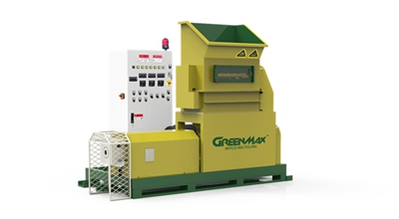The Greenmax MARS C100 is a machine manufactured by INTCO that melts expanded polystyrene (EPS), polystyrene paper (PSP), extruded polystyrene foam as insulation material (XPS), expanded polypropylene (EPP) and expanded polyethylene foam (EPE) to dense blocks. These compact bricks are easy to store and ship. The compression ratio is 90:1. GREENMAX Mars C100 has a capacity of 100 kg per hour. The machine was specially designed for Hot Melting plastic foam on a small scale, and the machine is easy to move. A Greenmax MARS C100 machine sells for $5,000 to $29,999 according to the Alibaba website. The machines are manufactured in Shanghai, China. There is only one contact number provided in China. The North American aftersales service center is located in Ontario Canada.

INTCO which purchases compact EPS for reuse, is willing to buy all type of PS scraps, including cold compressed logs; hot melt purge and PS renewable pellets, which are the major material for picture frame and decorative molding manufactured in China. Every year, INTCO recycles about 50,000 tons of EPS waste, which makes INTCO one of the world's largest end-users of EPS waste.

With self-owned AQSIQ certificate and other documents complying with Chinese laws and regulations, INTCO is one of the largest legal scrap importers in China. INTCO’s experience can help a recycler or manufacturer resolve any issues regarding exporting waste products to China.[5]

*RecyleTech XT 400*

The RecycleTech XT400 EPS Foam Densifier is a machine that can melt and densify 400 pounds of EPS foam per hour. The compression ratio is 90:1. The machine can be installed in a small space and is a cost effective solution for mid to large size operations. RecycleTech will buy back 100% of the densified EPS. RecycleTech claims to reduce waste hauling costs by up to 80 percent.

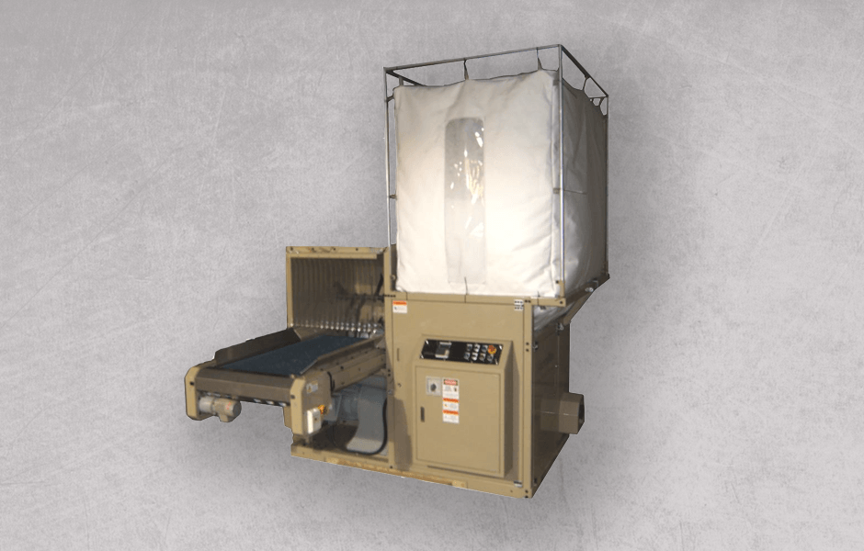RecycleTech is a U.S. company founded in 2004 as a specialized recycler of Expanded Polystyrene (EPS), Based in Ridgefield, New Jersey, RecycleTech Corp. set up its first processing facility in Lakeland, Florida in 2005. In 2008, A Florida Innovative Waste Reduction and Recycling Grant was awarded to RecycleTech to stop the flow of EPS waste into landfills. Since June of 2008, RecycleTech’s systems have saved over 1,607,000 cubic feet of landfill space in the State of Florida.[6] RecyleTech has over 100 commercial clients including Home Depot, General Motors, HP and General Electric.[7]

**Cool Compaction Densifiers**

*Harden Industries CP250*

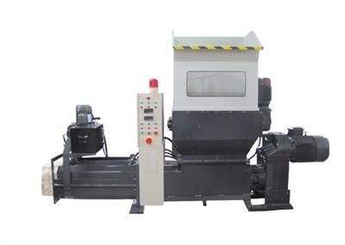HARDEN INDUSTRIES is the first developer of EPS cold compactor in China with their own R&D center. Usually, Styrofoam products are 98% air and only 2% PS. The operator of the compactor puts the used Styrofoam blocks into the hopper. The knives inside the compactor will shred the Styrofoam blocks into smaller flakes. The flakes will be pushed into the compaction chamber and be compressed, while the air inside the material is squeezed out. There is a pressure adjustment device at the end of the compression chamber which can adjust the volume reduction ratio. The compression ratio is 50:1. Although this is less compaction compared to briquette press, the screw driver compactor is much less expensive and operational cost is less. Compared to the melt extrusion densifier, the screw drive compactor avoids thermal deterioration and reduction of the material viscosity, it is energy saving, it generates no odor, and it is convenient for off-and-on operation.[8] Styrofoam/EPS/XPS foam blocks are compacted into densified logs and can be easily transport for further processing such as extrusion pelletizing. Cold compaction saves energy because no heat is required in the process.

A Harden Industries CP250 EPS Densifier sells for $7,000 to $12,000 according to the Alibaba website. The machines are manufactured in Guangzhou, China. The US support offices are located in Pennsylvania, Georgia and California.

*Mil-tek EPS 1800*

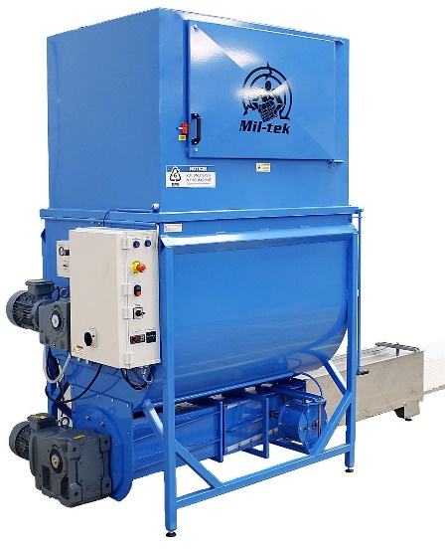 Mil-tek is a Danish company that was founded in 1992. The company has operations in 30 countries and the United States. Mil-tek has 14 locations in the United States, including Indiana. The US Headquarters is located in Sterling, Virginia. The company believes that “waste is an inevitable by-product of business. Moreover, waste handling poses a significant cost to most organizations. How organizations handle their waste dictates this cost, and in turn dictates the impact the business has on the environment as a whole.” They “believe that by optimizing your waste handling process, you not only reduce the cost to your organization, but you can turn your recycled waste into a revenue stream.”[9] Mil-tek’s products are ANSI, ISO14001, and CE certified. Safety in the usage of the product is paramount, and the Mil-tek machines are designed to be used safely by regular, non-qualified staff.

Mil-tek EPS 1800 has a compression ratio of 40:1 and it has a capacity of 70 kg per hour. The machine operates either with an air compressor or a standard AC outlet. A Mil-tek EPS Compactor works in two stages. First, the expanded polystyrene is shredded to remove the air (97%).The shredded material is then heated, compacted and reformed into a briquette, which is extremely dense (18 lbs. per cubic ft.) with an overall volume reduction of 40:1.

Mil-tek includes machine rental as an option on their website. Mil-tek has identified the following industries that would benefit from an EPS compactor: Manufacturing, Restaurants, Retail, Auto Manufacturers, Automobile Repair Shops, Hospitals, Medical Clinics, Residential Care Facilities, Hotels, Schools, Colleges and Universities. “Mil-tek assists companies to ensure they find a local recycler willing to take this off your hands.”[10]

**Business Opportunity Enhanced by State Grants**

States are realizing that landfills have limited capacity and they are incentivizing job creation and waste management programs modernization by providing recycling grants. Many of these grants provide a 50 percent match for the purchase equipment specifically needed to remanufacture recyclable materials into finished products or industrial feedstocks. Indiana[11], Illinois [12]and Ohio[13] all have 2016 recycling grants in place. Illinois has not yet funded their program due to a state budget deadlock. Manufacturers often cannot obtain sufficient scrap and must rely on “new” petroleum based EPS resin beads for their products. Polystyrene foam recycling is a business of great potential.

**Conclusion**

The recycling of Expanded Polystyrene (EPS6) is commercially feasible. Municipal Solid Waste Districts and concerned organizations can recycle EPS6 cost effectively and can transport densified product to provide feed stock for the next use. Recycling becomes even more commercially feasible when combined with a state funded grant which can reduce up to half of the purchasing costs of required densification machines. As noted the problem with all recyclables is the cost of collection and transportation. With densification EPS recycling has the potential of becoming the priority focus for cities and municipalities that want to avoid its internment in landfills. Without recycling/reuse efforts, EPS6 is among the longest lasting poly product (plastic) in landfills with an estimated life span of at least 500 years.

**Appendix A**

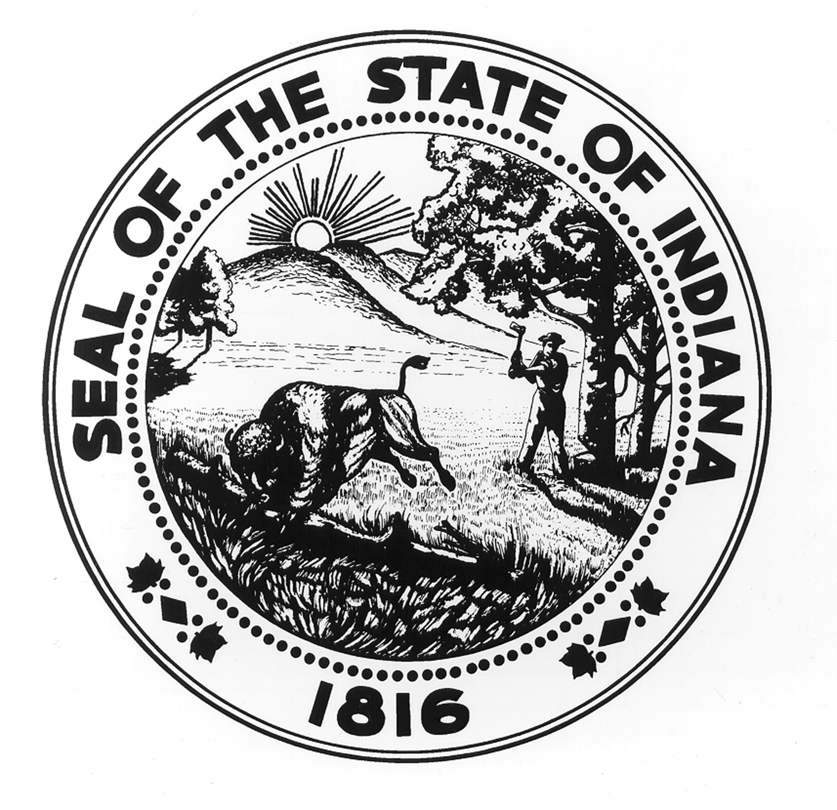  **GRANT InsTRUCTIONS**

**Recycling Market Development Program**

**please read this document in its entirety before submitting**

**an official application for the Recycling Market development grant.**

**INTRODUCTION**

**OVERVIEW**

**QUICK FACTS**

**Eligible Entities:** Indiana businesses

**Amount:** $25,000 to $200,000 in grant funds

**Purpose:** Develops Indiana’s recycling markets by aiding the financing of equipment specifically needed to manufacture or remanufacture recyclable materials into an industrial feedstock or finished product.

The Recycling Promotion and Assistance Fund allows Indiana businesses to purchase equipment specifically needed to remanufacture recyclable materials into finished products or industrial feedstocks. The fund is distributed through the Recycling Market Development Program and is administered by the Indiana Department of Environmental Management (IDEM). The Program operates under the auspices of the Recycling Market Development Board as established by IC 4-23-5.5-14.

Prospective applicants are required to provide a 50 percent match to the amount requested. The minimum grant amount an applicant may request is $25,000; the maximum grant amount an applicant may request is $200,000. All grants are made in $25,000 increments. What this means is that if you have eligible total project costs that are more than $400,000, you may apply for the full $200,000. If you have eligible total project costs that are at least $50,000, you may apply for $25,000. In contrast, if you have an eligible total project cost of $85,000, the total amount you could apply for would be $25,000 (The total project amount in this example does not equal or surpass $100,000, and therefore cannot be matched by a $50,000 grant.)

Grants may be made in conjunction with private-sector lending sources, equity from owners or investors, or other private sources. The state expects all applicants to bear the financial risk of the proposed project. An investment of approximately 10 percent of true equity will be required in every project.

**ELIGIBILITY**

Eligibility for this grant is limited to businesses that operate in Indiana or will operate in the state as a result of the project. All projects must occur in Indiana; be based on a technology that has been demonstrated beyond the research stage; be technically feasible for full-scale operation; and comply with all applicable environmental, safety and legal regulations. Commercially proven projects are preferred. Eligible projects include those resulting in the final processing or conversion of secondary recyclable materials[14] into industrial feedstock; or the manufacture of products from those feedstocks.

*Restrictions of the RMDP include:*

* *Businesses must not have a grant or loan opened currently through the RMDP.*
* *An applicant must wait two years from the last board-approved date of a project to request funding for another project.*
* *The maximum total amount that may be requested from the RMDP is $500,000.*

**PROJECT EXPENSES**

The following is a summary of eligible versus ineligible project expenses. Eligible project expenses include those expenses that can be designated toward grant and project match funds.[15]

|  |  |
| --- | --- |
| **Eligible Project Expenses** | **Ineligible Project Expenses** |
| * Purchase of specialized manufacturing equipment and machinery or the conversion of existing equipment and machinery. * Related equipment costs (including shipping and installation costs up to 10 percent of the total grant amount). * Site improvements such as refurbishing the infrastructure of a building for assembly lines, process flow, equipment or stock accessibility, up to 10 percent of the total grant amount. | * Secondary material collection costs. * General land and site improvements (related to property resale value). * Purchase of land or buildings or vehicles. * Required licenses or permits. * Legal costs. * Indirect or overhead expenses including office equipment, personal services or travel costs. * Any grant-related expenditure made prior to the effective date of the grant agreement. |

**GENERAL REQUIREMENTS**

The following are general eligibility requirements for every applicant:

* All applicants must be a registered business within the state of Indiana to receive funding. To find out more about setting up a business in this state, contact the Secretary of State’s Office at 317-232-6531 or visit their website at <http://www.in.gov/sos/>. Not for profits businesses are not eligible for funding.
* All applicants must be in compliance with state and federal rules and regulations. To find out what permits may be necessary for your business, visit the IDEM Permit Wizard at <http://www.in.gov/ai/appfiles/permitwizard/>.
* Entities must maintain goals that are consistent with the state’s interest and vision of proper solid waste management, including diverting priority materials from landfills or final disposal which could be re-used or reprocessed. Priority materials include but are not limited to: plastics, mixed glass, construction and demolition debris, foundry sand, wood, metals, and electronics. Other projects, such as composting food waste, are considered on a case by case basis.

**FUNDING AND EVALUATION PROCESS**

**FUNDING PROCESS**

The Recycling Market Development Grant is part of the Recycling Market Development Program (RMDP). The program financially assists businesses in the creation and continuous development of recycling markets in Indiana. The Office of Compliance Support (OCS) of IDEM oversees management of the grants and execution of the contracts.

Application

A formal application form is posted on the *Recycle Indiana* website to be completed by eligible entities. A project evaluation will take place following the submission of the application. Applications which fail to meet requirements or are not complete will not be evaluated further. OCS reserves the right to request additional information and documentation from applicants.

**The application must be printed double-sided on post consumer recycled content paper and bound in a way that allows photocopying. Include at least two copies of all materials along with an original, signed in blue ink.**

Applicants must provide the following information:[16]

* Completed cover page.
* Project information, including:
  + Estimates of annual waste diversion.
  + Estimates of the total energy savings.
  + Description type of material to be collected and recycled.
  + Documented sources of recyclable feedstock and projected annual consumption or throughput (outputs per hour) of each grade of materials.
  + Letters of contracted sources (including potential support) of materials.
* Discussion of the technical information, including:
  + Project site.
  + Operation of the recycling process, system or technologies employed, including design specifications, and a chronological list of activities/developments leading to project justification.
* Detailed timeline for project.
* Verification of the market, including:
  + Market service area and demand for products.
  + Evidence of buyers, including letters of intent.
  + Description of service area.
  + Listing of competitors.
* Listing of current employees and estimated net new employees by job title and skill level.
* Listing of key people and experience in field, as well as grant management.
* Summary of project funding including evidence of financial commitment from management and project partners.
* Project budget and listing of equipment to be requested.
* Summary of all required federal, state and local permits, licenses, authorizations, etc. required for the project and their current status. **Applicants must show they have started the permit application and approval process** (if applicable).
* Financial documentation, including:
  + Explanation of company structure, including parent company and all affiliates, (if applicable).
  + Documentation including:
    - Financial statements.
    - Federal Income Tax returns.
    - Current leasing agreements.
* Net Present Value calculations, estimating how profitable the project or investment will be.
* Lender information.
* Commitments for other elements of the financing package. Grants will be considered for presentation to the Recycling Market Development Board (RMDB) only after written commitments from other funding sources have been received.
* Completed, detailed business plan.

**EVALUATION PROCESS**

Successful applications will be evaluated on the following:

* Completeness of submitted information.
* Environmental Impact. This includes reviewing type and amount of materials to be recycled or reduced, energy savings, and permits received or in process (if applicable). Emphasize priority materials and increased landfill diversion rate resulting from the project. (See the third bullet point in the General Requirements section on page 2 for a listing of priority materials.)
* Materials and Markets. This includes reviewing the type of materials to be recycled. Show markets have been researched and sources of materials have been established, and that there is a plan to promote products/services.
* Project Plan: This includes reviewing for project need, project objectives and significance of objectives toward developing a recycling business within predicted timelines. This information should allow transferable technology for similar future projects in Indiana.
* Organizational structure and experience. This includes reviewing the experience management and employees have in the given field.
* Economic development benefits. This includes reviewing for job creation, employment of Indiana residents, capitol investment in the state, revitalizing distressed regions and communities, wages of employees, worker training, increased productivity and increased competitiveness of the applicant’s facility.

**RECYCLING MARKET DEVELOPMENT BOARD**

Funding decisions are made by the Recycling Market Development Board. Once an application has been evaluated by IDEM staff, OCS sends the application and supporting documentation to the Board for review. Funding recommendations for all projects are made by the Board. The Board meets on a quarterly basis every February, May, August, and November. Final decisions regarding the availability of funds for all projects are made by the State Budget Office.

**RESPONSIBILITIES of the GRANTEE**

Upon Board approval, OCS staff will develop a contractual Grant Agreement (the “Agreement”) between the state and the applicant (the “Grantee”). The Agreement is sent to the Grantee to be reviewed and signed. After this paperwork is properly completed and returned, OCS will forward the Agreement through the state signature process. The Agreement must then be approved and signed by IDEM's Commissioner; the Indiana Department of Administration; the Indiana State Budget Agency; and the Indiana Attorney General's Office. The effective date of the grant will be the date on which the Agreement is signed by the Attorney General's Office (also referred to as the contract execution date).

Applicants must receive notice that the Agreement has been signed by all state signatories **before**any purchases are eligible for reimbursement of funds. Any purchases made outside the term of the Agreement will not be reimbursed. Execution of the Agreement may take up to three months to be completed. To avoid delay in an organization’s process or plans, please keep in mind the quarterly application deadlines when applying for the grant and allow adequate time for execution of the contractual Agreement before expenditures are made.

**Any grant-related expenditure made prior to the start date of the grant agreement (i.e., the date on which the agreement is signed by the Attorney General’s Office) will not receive reimbursement.**

A Vendor Information Form will be sent in advance of the Grant Agreement package. Please return the form to OCS as soon as possible. Before approving the contract for processing, OCS staff will initiate compliance checks with the Departments of Workforce Development and Revenue to make sure applicants are in good standing with the state. Cooperation to confirm that all tax and employer/employee information is up to date with these agencies upon receipt of the Grant Agreement package will expedite the contract process.

**GRANT TERM**

The Grant Agreement specifies the total monetary award and stipulates exactly how the recipient will spend the funds. The grant term will commence on the date the Attorney General's Office signs the grant agreement (i.e., the contract execution date). The duration of the grant term is one year from the contract execution date. All drawdowns for grant funds must be expended within the grant term. The appropriate receipts and forms must be submitted to OCS as described in the Grant Agreement and before the end of the grant term.

**grant Fund Disbursement**

Grantees receive up to fifty percent (50%) of the total project costs through reimbursement from the state. This means that after the Agreement has been executed through the state signature process the grantee may expend the grant funds, submit the appropriate reimbursement documentation to OCS, and be reimbursed up to fifty percent of the qualified invoices submitted. For example: a Grantee submits a receipt for the purchase of a small grinder, showing an amount paid of $50,000 with a zero balance remaining. This will be matched by the state with a direct deposit amount up to $25,000 into the Grantee’s designated account provided in the Vendor Information form.

*The preceding guidelines are intended to aid grant applicants in submitting quality applications for the IDEM review process. Grant application rounds will be competitive, as requests for grant funding are expected to exceed available funds. There is no implied guarantee of funding for a submitted grant proposal, even if the grant application meets all desired expectations.*

**REPORTING REQUIREMENTS**

The Indiana Department of Environmental Management will require grantees to submit progress reports for three years after the grant term; including a final close out report. Information requested will include the amount and type of waste collected and recycled, the number of jobs added and maintained as a result of the project, and any other benefits afforded from the funding.

OCS may conduct site visits to evaluate the progress of the project during the one year grant term. OCS staff will notify the grantee before the site visit occurs.

**PROGRAM BACKGROUND**

**Recycling Market Development Program**

The Recycling Market Development Program (RMDP) is designed to promote and assist recycling throughout Indiana by focusing economic development efforts on businesses and projects involving recycling. Grant opportunities are offered through the RMDP to financially assist businesses in the creation and continuous development of recycling markets in Indiana. These grants are administered by the Office of Compliance Support.

The grant money for the Recycling Market Development Program comes from the Recycling Promotion and Assistance Fund (RPAF) as established under Indiana Code 4-23-5.5-14. The RPAF receives one-half of the Solid Waste Management Fee, a $.50 per-ton charge on final disposal of solid waste at Indiana landfills established by Indiana Code 13-20-22-1(b)(1). The RPAF supports source reduction, reuse, recycling and composting to prevent solid waste from permanent disposal. The money is awarded by the Recycling Market Development Board as established under Indiana Code 4-23-5.5.

**Indiana Department of Environmental Management**

IDEM implements federal and state regulations regarding the environment. Through compliance assistance, incentive programs and educational outreach, the agency encourages and aids businesses and citizens in protecting Hoosiers and the environment.

For more information about the **Recycling Market Development Program** please contact:

Office of Compliance Support

Indiana Department of Environmental Management

100 North Senate Avenue

MC 64-02, IGCN N1316

Indianapolis, IN 46204-2251

Telephone: (800) 451-6027

Fax: (317) 233-6647

[www.recycle.IN.gov](http://www.recycle.IN.gov)

1. **Endnotes**

   Recycler’s World, PS Polystyrene Recycling Exchange Listings, <http://www.recycle.net/Plastic/ps/xv100600.html>
2. Green Living Tips, Recycling polystyrene – aka Styrofoam, Sept 30, 2009, <http://www.greenlivingtips.com/articles/Recycling-styrofoam.html>
3. Dart, PS Foam Recycling, https://www.dartcontainer.com/environment/ps-foam-recycling/.
4. Packaging Digest, Getting more out of recycled EPS, June 30, 2013, <http://www.packagingdigest.com/smart-packaging/getting-more-out-recycled-eps>
5. Greenmax INTCO Recycling, <http://www.intcorecycling.com/>
6. RecyleTech The Environment Savers, About Us, <http://www.recycletechno.com/about-2/>
7. RecyleTech The Environment Savers, Our Clients, <http://www.recycletechno.com/current-operations-locations/>
8. Harden, EPS Compactors, <http://www.eps-compactor.com/en/>
9. Mil-tek, Minimize your waste, Why Mil-tek?, <http://www.miltekusa.com/why-mil-tek>
10. Mil-tek, Minimize your waste, Quality and Environmental Policy, <http://www.miltekusa.com/why-mil-tek/quality-environmental-policy>
11. IN.gov, Recycling Market Development Program, <http://www.in.gov/idem/recycle/2358.htm>
12. Illinois Department of Commerce & Economic Opportunity, Recycling Expansion and Modernization (REM) Program, <http://www.illinois.gov/dceo/whyillinois/KeyIndustries/Energy/Recycling/Pages/REM_Program.aspx>
13. Ohio EPA, Ohio EPA accepting recycling grant applications, <http://www.ccao.org/userfiles/151009%20OH%20EPA%20grants.pdf>
14. Secondary recyclable materials include post-consumer materials (i.e., business and household products that have served their intended end uses and have been separated from the waste stream for purposes of recycling), industrial scrap materials, and overstock and obsolete inventories. This does not include materials and byproducts generated from and commonly reused within an original process.
15. Eligible project expenses include, but are not limited to those listed in the table. If you are unsure whether a project expense is eligible for RMDP funding, please contact the RMDP Manager.
16. **Confidential Information**

    To the extent feasible and permissible by law, the Indiana Department of Environmental Management (IDEM) will honor an applicant's request that confidential information submitted to IDEM remain confidential. IDEM will treat information as confidential only if: (1) the information is in fact protected confidential information such as trade secrets or privileged or confidential commercial or financial information, (2) the information is specifically marked or identified as confidential by the applicant, (3) the information is segregated and placed in a separate appendix to the application, and (4) no disclosure of the information is required by law or judicial order. If the application results in a grant, the honoring of confidentiality of identified data shall not limit IDEM's right to disclose general project information (not proprietary information) and results to the public. Each and every page containing proprietary data must be clearly identified and marked CONFIDENTIAL.